InAmigos Foundation

Website Improvement Analysis

Website : https://inamigosfoundation.org.in/
- No Denate button in Navigation
The nav bar has 8 text links but no Donate button — the most important action for an NGO site. Fix: Add a green/orange "Donate Now" button on the right side of the navbar, visible on every page.

- Too many CTA Buttons -confusing
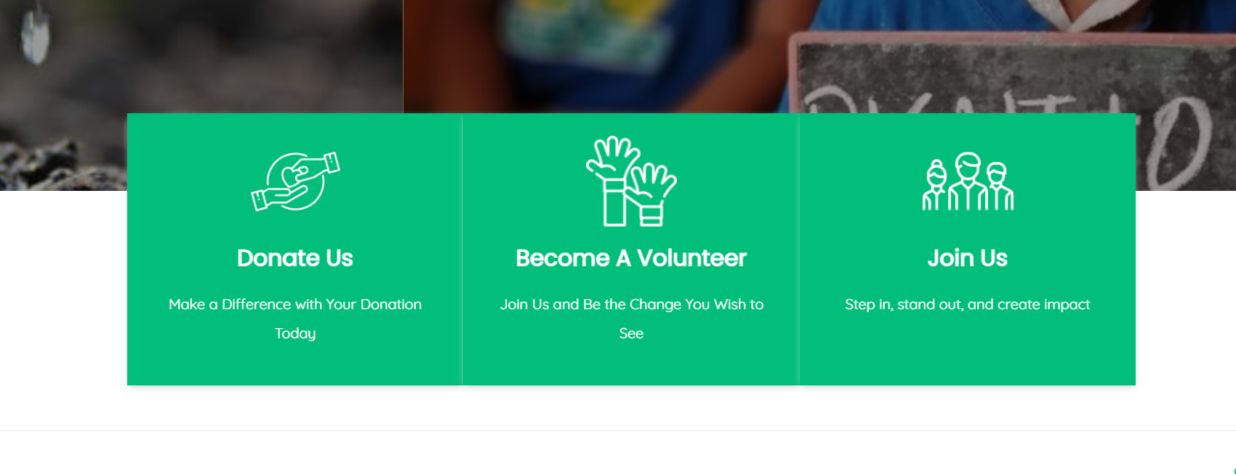
"Donate Us", "Become A Volunteer", and "Join Us" are three nearly identical buttons in a row. "Donate Us" is also grammatically incorrect (should be "Donate Now"). Fix: Keep just two buttons — "Donate Now" (primary, filled) and "Volunteer" (secondary, outlined).

- Interns information
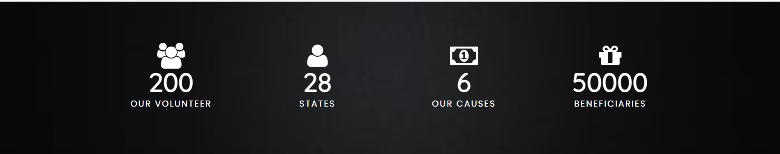The 4 statistics (200 volunteers, 28 states, 6 causes, 50,000 beneficiaries) are a great trust signal. Suggestion: Make them larger and more prominent. Also add "30,000+ Interns Trained" which is currently missing from this row.

- Causes
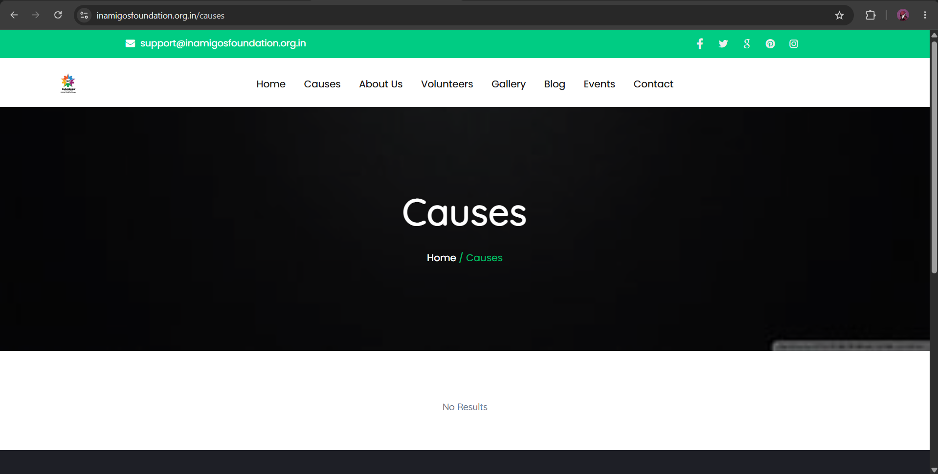There is no information in causes section

- Upcoming Events /Blogs
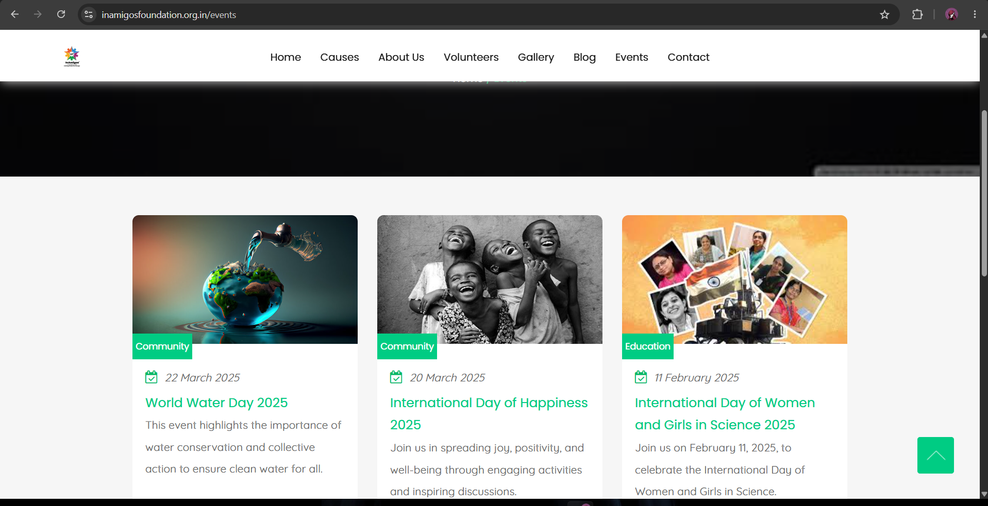All events listed are from February–March 2025. There are no upcoming events, making the organisation appear inactive. Fix: Add an “Upcoming Events “Section and same for blog to keep it active

